

**MOIC User Manual**



Copyright © **CIGNEX**

This document and content therein are for the sole use of the intended recipient(s) and may contain confidential and privileged information. Any unauthorized review, use, disclosure, dissemination, forwarding, printing or copying of this document or any action taken in reliance on this document is strictly prohibited and may be unlawful.

Visit us at [www.CIGNEX.com](http://www.CIGNEX.com/)

**Revision History and Approval Chart**

|  |  |  |  |
| --- | --- | --- | --- |
| **Ver** | **Reviewed /Approved** | Author(s)/ Approver | Description |
| 0.1 | 20-02-2021 | Vatsal Thakkar | Draft |
| 0.2 | 22-02-2021 | Vatsal Thakkar | Updated for more details on Uploads |
| 1 0 | 25-02-2021 | Vatsal Thakkar | Base line version |
| 1 1 | 04-04-2021 | Vatsal Thakkar | Updated for (Preview Functionality, Overview report, Audit Report, Users/Roles) |
|  |  |  |  |

Table of Contents

1. Introduction 4

1.1. Document Overview 4

1.2. Scope of Document 4

1.3. Intended Audience 4

2. Application Overview 4

2.1. Different Jobs that communicate with SAP / Joor / PMDB 4

2.2. Lookup / Default Tables used in MOIC 5

2.3. Rules 6

3. Application - Screens 8

3.1. Launch 8

3.2. Overview Screen (Landing Page) 8

3.3. MOQ Screen 11

3.4. SKU Change Screen 16

3.5. UPC Validation Screen 21

3.6. S4 Upload File Screen 22

3.7. Config Screen 24

3.8. Audit Report 27

4. Uploads 28

4.1. Customer Data Upload 28

4.2. MOQ List Upload 30

4.3. SKU Change Upload 31

4.4. Pre Buy Upload 33

# Introduction

## 

## Document Overview

This document serves as the User Manual or User Guide for users intending to use MOIC (Market Orders Intake Consolidation) application.

## Scope of Document

Scope of the document is to provide details of default setup of MOIC application and on screen functionality with logic that is implemented.

## Intended Audience

MOIC application users, admin team & support team.

# Application Overview

Tapestry has developed a custom solution that can provide real time reconciliation between demand (Orders) and production / targets. MOIC web application communicates with external systems through the middleware layer (ESB) and (ETL) for data (Inbound & Outbound)

* Order Data from Joor
* Customer Data from SAP / S4
* Product Data from PMDB

The business users able to view the consolidated data through MOIC application screens and manipulate / change as required. The changes done through MOIC screens are updated in MOIC database and the relevant data is communicated back to external systems (Joor / SAP) through middleware layer.

MOIC application is developed using Spring Boot which is an open source JAVA based framework for the backend and Angular JS for the front end. MOIC uses Postgres as the relational database engine.

MOIC takes the Orders data from Joor, Customer Master Data from SAP and Product Master Data from PMDB. For this, different jobs are developed as part of MOIC application as well as by middleware teams.

Updates to the consolidated data can be done through MOIC screens and also through Excel imports in case of bulk updates.

## Different Jobs that communicate with SAP / Joor / PMDB

There are mainly two mechanisms used for data communication between MOIC and other systems.

* Data communication – table to table

The data set which is not needed in real time is communicated through this mechanism. ETL is used as the middleware for this operation. The following details the jobs with its purpose under this bucket.

|  |  |  |  |
| --- | --- | --- | --- |
| *Entity Name* | *Purpose* | *Frequency* | *Load* |
| Customer Master | Extract from SAP and push it into MOIC Inbound staging table | Once | Full |
| Customer Master | Process from MOIC Inbound staging table to main MOIC table | Once | Full |
| UPC Codes | Extract from A360 and push it into PMDB staging table | Twice | Delta |
| UPC Codes | Process from PMDB staging table to main PMDB table | Twice | Delta |
| Product Master | Extract from PMDB main tables and push it to PMDB Outbound staging tables | Twice | Delta |
| Product Master | Transfer from PMDB Outbound staging tables to MOIC Inbound staging tables | Twice | Delta |
| Product Master | Process from MOIC Inbound staging tables to main MOIC tables | Twice | Delta |
| Buy Upload | Extract from MOIC Outbound staging table and push it into SAP through iDOCS | Twice | Full |

* Data communication – through files (JSON)

The data set which could be needed in near to real time is communicated through this mechanism. ESB is used as the middleware for this operation.

|  |  |  |  |
| --- | --- | --- | --- |
| *Entity Name* | *Purpose* | *Frequency* | *Load* |
| Sales Orders | Extract Orders from Joor and pass it to MOIC | Twice | Full |
| Sales Orders | Process the Orders JSON into main MOIC tables | Twice | Full |
| Customer Master | Extract Customer data from MOIC main tables into JSON for sending to Joor | Once | Delta |
| Customer Master | Process the Customers JSON to Joor | Once | Delta |

## Lookup / Default Tables used in MOIC

Listed below are the lookup / default tables with values used in MOIC.

* Channel (Used at the filter level)
  + Domestic Wholesale
  + EMEA Wholesale
  + KDF Wholesale
  + SEA Wholesale
  + China TR Wholesale
  + Off Price Wholesale

Note 1: This table is pre-populated in MOIC main schema.

Note 2: There is no user interface to perform CRUD operation on this table. This has to be managed through Support team.

* Segment (Used at customer level)
  + ECM
  + RTL
  + RTLP
  + WHS
  + RTO
  + INS

Note 1: This table is pre-populated in MOIC main schema.

Note 2: There is no user interface to perform CRUD operation on this table. This has to be managed through Support team.

* Currency Conversion (Used for currency conversion)
  + EUR : 1.2 USD
  + CAD : 0.79 USD
  + JPY : 0.0095 USD
  + GBP : 1.41 USD
  + CHF : 1.11 USD
  + USD: 1.00 USD

Note 1: This table is pre-populated in MOIC main schema.

Note 2: There is no user interface to perform CRUD operation on this table. This has to be managed through Support team.

* Users (used for managing users with roles within MOIC)
  + There are 2 roles defined within MOIC
    - Admin (all screens and functionalities available)
    - System (all screens except audit report available)

## Rules

The default rules applicable to MOIC application are listed below.

* The landing page when the user hits application URL is the “Overview” page.
* There are two filters (drop down) on almost all screens. The first value in the drop down will be selected on the screen by default. The user can select a different value by using the drop downs.
  + Fashion Season
  + Channel
* The Channel drop down has a non-channel value called “Corporate”. When “Corporate” is selected in the drop down, it means select all Channels in all computations on the screen.
* All the uploads and downloads will only work if all the validation parameters such as file name, number of columns in the file, sequence of columns, data types of the column are correctly used. The exact format and details are given in the screens section of this document.

# Application - Screens

## Launch

* The user will hit <https://myapps.microsoft.com>  by entering his Tapestry Email address and Password.
* Once the user is logged in, he would see the below icon in his dashboard.



* Clicking this icon, Azure will send the authenticated user’s metadata  to MOIC URL : <https://moicdev.tapestry.com/auth/login>
* MOIC backend (spring boot) will read the XML, parse the session token and communicate the same to MOIC front end (Angular).
* Angular will redirect the user to landing page.

## Overview Screen (Landing Page)

The user after getting authenticated from Azure AD will get redirected to this screen which is configured as the landing page for MOIC application.

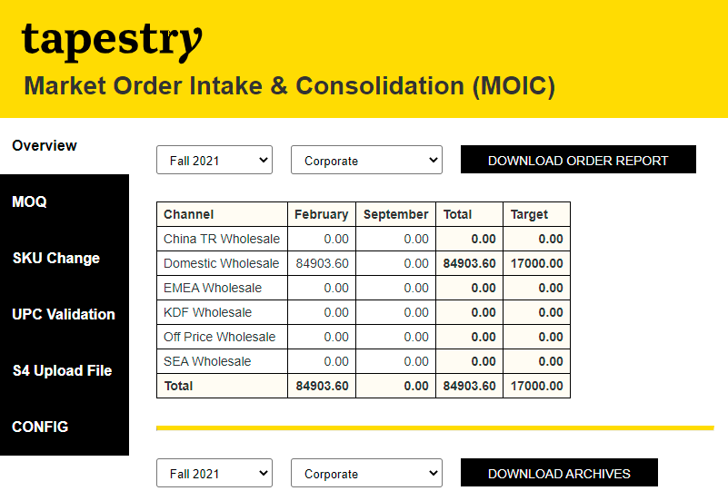

Section 2

Section 1

* **Section 1 contains:**
  + **Filter 1: Fashion Season**
    - This is populated with distinct Season Names which come from Joor Orders (Orders Data)
    - Default selection is the first value in the list
  + **Filter 2: Channel**
    - This is populated with Channels which are pre-populated in the Channel look up table
    - Default selection is the first value in the list
  + **Button: DOWNLOAD ORDER REPORT**
    - Clicking on this button downloads the order data in form of an excel file.
    - The name of the download file will be “Orders Report” + <<Fashion Season>> selected from the dropdown + <<Channel>> selected from the drop down + date time stamp.
    - For e.g. Order Report_Fall 2021_Corporate_24-02-2021 13_35_49.xls
    - The orders will be filtered based on the selection in both filters; Fashion Season and Channel
  + **Table: Data table (Orders data)**
    - The first column lists all the channels for which there will be orders present in the orders coming from Joor.
    - The month columns are derived from the Orders (date_ship_start) value.
    - The numeric values represent the order values for a given month and against the given channel.
    - The Total column is just the Sum of orders from all months.
    - The Target column displays the Sum of target value set at customer level for a given channel.
* **Section 2 contains:**
  + **Filter 1: Fashion Season**
    - This is populated with distinct Season Names which come from Joor Orders (Orders Data)
    - Default selection is the first value in the list (as shown in the snapshot below)

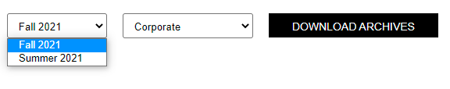

* + **Filter 2: Channel**
    - This is populated with Channels which are pre-populated in the Channel look up table
    - Default selection is the first value in the list (as shown in the snapshot below)

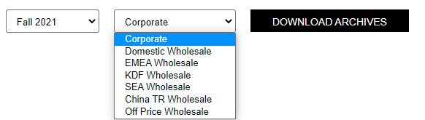

* + **Button: DOWNLOAD ARCHIVES**
    - Clicking on this button downloads the “archived” order data in form of an excel file
    - All the orders that are sent from MOIC to S4 (Buy Upload) are also archived in a separate archive table
    - The archived orders are kept for a period of 2 years
    - The orders will be filtered based on the selection in both filters; fashion season and channel
    - The name of the download file will be “Archived Orders” + <<Fashion Season>> selected from the dropdown + <<Channel>> selected from the drop down + date time stamp.
    - For e.g. Archived Orders_Fall 2021_Corporate_24-02-2021 13_42_54.xls

## MOQ Screen

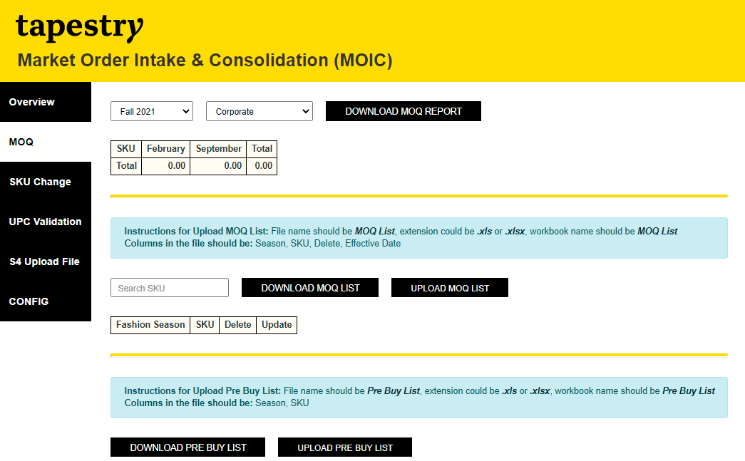

Section 3

Section 2

Section 1

* **Section 1 contains:**
  + **Filter 1: Fashion Season**
    - This is populated with distinct Season Names which come from Joor Orders (Orders Data)
    - Default selection is the first value in the list
  + **Filter 2: Channel**
    - This is populated with Channels which are pre-populated in the Channel look up table
    - Default selection is the first value in the list
  + **Button: DOWNLOAD MOQ REPORT**
    - Clicking on this button downloads the order data in form of an excel file.
    - The orders that are impacted by MOQ as per the MOQ list uploaded in the system will make it into the download report.
    - The name of the download file will be “MOQ Report” + <<Channel>> selected from the dropdown + <<Fashion Season>> selected from the drop down + date time stamp.
    - For e.g. MOQ Report_Corporate_Fall 2021_24-02-2021 14_57_36.xls
    - The orders will be filtered based on the selection in both filters; Fashion Season and Channel
  + **Table: Data table (Orders data)**
    - The first column lists all the SKUs for which there will be orders present in the orders coming from Joor.
    - The month columns are derived from the Orders (date_ship_start) value.
    - The numeric values represent the order values for a given month and against the given channel.
    - The Total column is just the Sum of orders from all months.
* **Section 2 contains:**

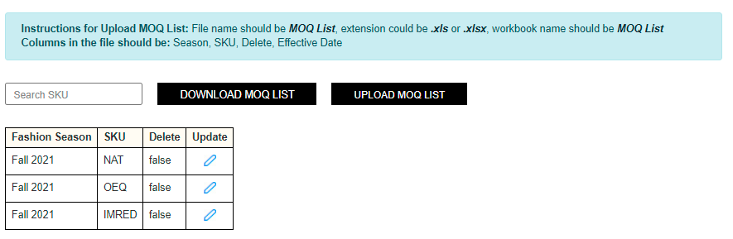

* + **Search Box: Search SKU**
    - This enables user to search and narrow down the MOQ list displayed on the screen based on “SKU”.
    - The search happens as soon as a character is typed in the search box.
    - The result set in the data table gets narrowed down based on user’s input in the search box as shown in the snapshot below

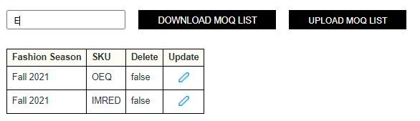

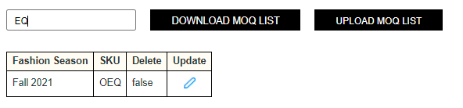

* + **Button: DOWNLOAD MOQ LIST**
    - Clicking on this button downloads the MOQ list data in form of an excel file.
    - The name of the download file will be “MOQ List” + <<Fashion Season>> selected from the drop down + date time stamp.
    - For e.g. MOQ List_Fall 2021_24-02-2021 14_57_36.xls
    - The data set will be filtered based on the selection in Fashion Season filter.
  + **Button: UPLOAD MOQ LIST**
    - The user can upload MOQ list in the system through this button.
    - The instructions for uploading MOQ list (such as file name expected, columns expected in the file, etc.) are displayed on the screen itself as shown in snapshot below.
    - A message is displayed to the user on the screen upon successful upload or in case of any failure. Both examples are shown in snapshots below.



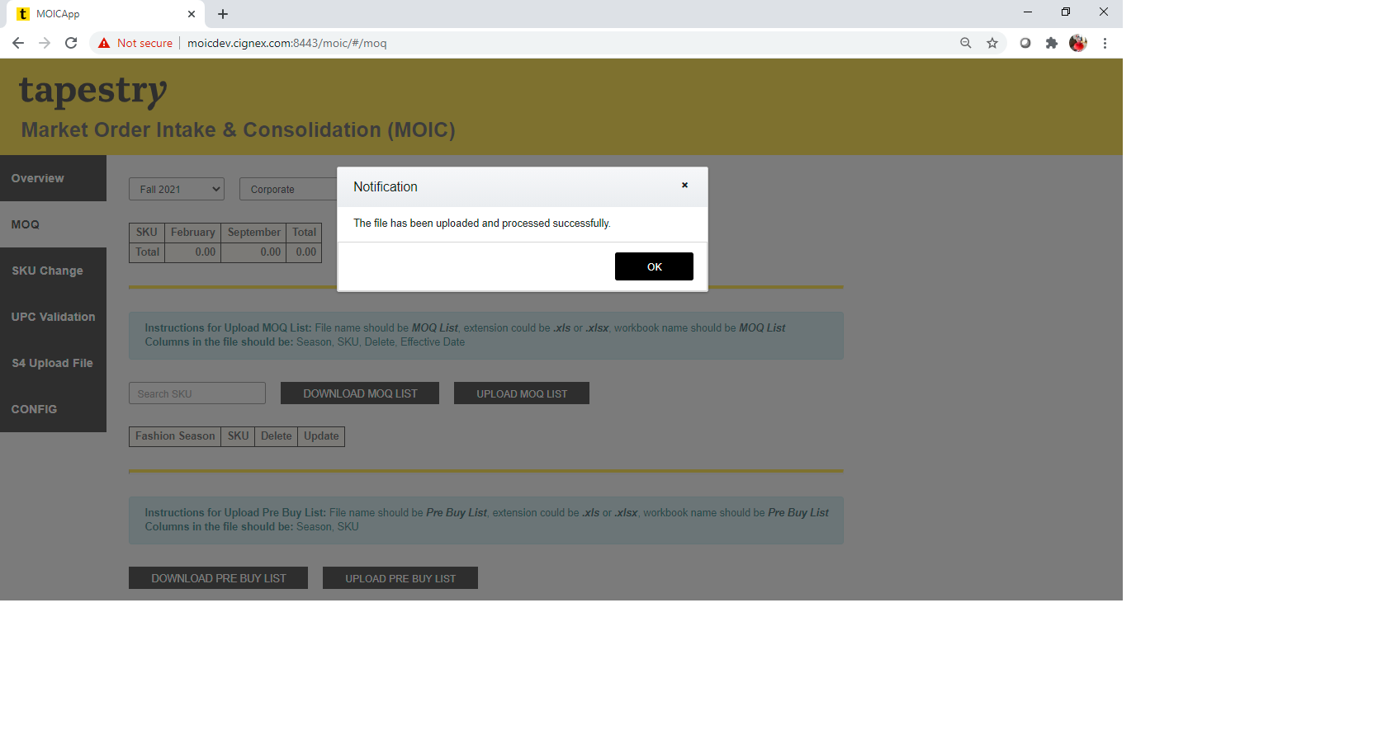

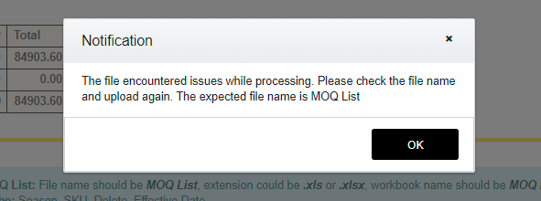

* + **Table: Data table (MOQ list data)**
    - The data in the table is filtered based on the “Fashion Season” selected in Filter 1 of section 1.
    - The first column lists the Fashion Season which matches with the value selected in Filter 1 of section 1.
    - The second column lists the SKUs from MOQ list for the fashion season selected.
    - The third column is a flag to determine if a record should be deleted from the MOQ list.
    - The fourth column allows the user to update that specific record. Clicking on the update button changes the record / row on the screen for in-line editing as shown in the snapshot below. After editing the editable fields, the user can save or cancel by clicking on either of the icons from Update column.

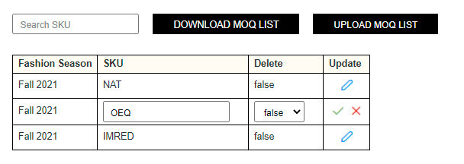

* + - After editing the editable fields, the user can save or cancel by clicking on either of the icons from Update column as shown above.
    - **Validation:** Upon saving the updates, a validation on SKU is done to check whether the updated SKU exists in the Orders SKU list. The update is preserved only if the SKU exists in the list otherwise the update is rejected.
* **Section 3 contains:**

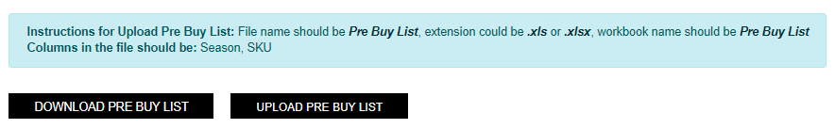

* + **Button: DOWNLOAD PRE BUY LIST**
    - Clicking on this button downloads the PRE BUY LIST data in form of an excel file.
    - The name of the download file will be “Pre Buy List” + date time stamp.
    - For e.g. Pre Buy List_24-02-2021 14_57_36.xlsx
  + **Button: UPLOAD PRE BUY LIST**
    - The user can upload PRE BUY LIST in the system through this button.
    - The instructions for uploading PRE BUY LIST (such as file name expected, columns expected in the file, etc.) are displayed on the screen itself as shown in snapshot above.
    - A message is displayed to the user on the screen upon successful upload or in case of any failure. Both examples are shown in snapshots below.

## SKU Change Screen

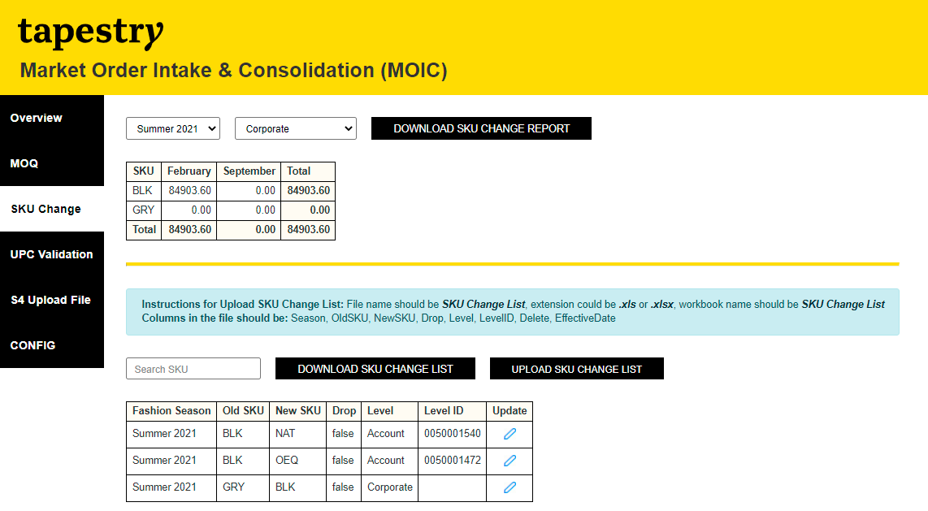

Section 1

Section 2

* **Section 1 contains:**
  + **Filter 1: Fashion Season**
    - This is populated with distinct Season Names which come from Joor Orders (Orders Data)
    - Default selection is the first value in the list
  + **Filter 2: Channel**
    - This is populated with Channels which are pre-populated in the Channel look up table
    - Default selection is the first value in the list
  + **Button: DOWNLOAD SKU CHANGE REPORT**
    - Clicking on this button downloads the order data in form of an excel file.
    - The orders that are impacted by SKU CHANGE as per the SKU CHANGE LIST uploaded in the system will make it into the download report.
    - The name of the download file will be “SKU Change Report” + << Fashion Season >> selected from the dropdown + <<Channel>> selected from the drop down + date time stamp.
    - For e.g. SKU Change Report_Summer 2021_Corporate_24-02-2021 14_57_36.xlsx
    - The orders will be filtered based on the selection in both filters; Fashion Season and Channel
  + **Table: Data table (Orders data)**
    - The first column lists all the SKUs for which there will be orders present in the orders coming from Joor.
    - The month columns are derived from the Orders (date_ship_start) value.
    - The numeric values represent the order values for a given month and against the given channel.
    - The Total column is just the Sum of orders from all months.
* **Section 2 contains:**

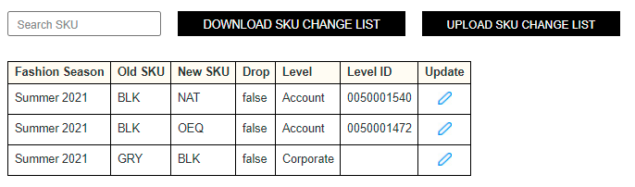

* + **Search Box: Search SKU**
    - This enables user to search and narrow down the SKU Change list displayed on the screen based on “SKU”.
    - The search happens on “OLD SKU” column as soon as a character is typed in the search box.
    - The result set in the data table gets narrowed down based on user’s input in the search box as shown in the snapshot below

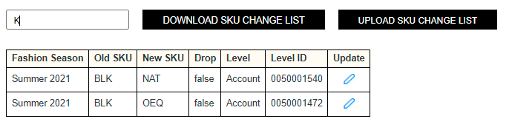

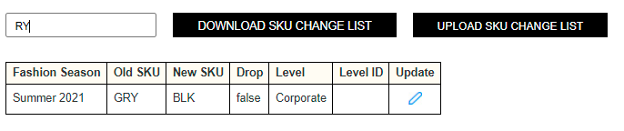

* + **Button: DOWNLOAD SKU CHANGE LIST**
    - Clicking on this button downloads the SKU CHANGE LIST data in form of an excel file.
    - The name of the download file will be “SKU Change List” + <<Fashion Season>> selected from the drop down + date time stamp.
    - For e.g. SKU Change List_Summer 2021_24-02-2021 14_57_36.xls
    - The data set will be filtered based on the selection in Fashion Season filter.
  + **Button: UPLOAD SKU CHANGE LIST**
    - The user can upload SKU CHANGE LIST in the system through this button.
    - The instructions for uploading SKU CHANGE LIST (such as file name expected, columns expected in the file, etc.) are displayed on the screen itself as shown in snapshot below.
    - A message is displayed to the user on the screen upon successful upload or in case of any failure. Both examples are shown in snapshots below.



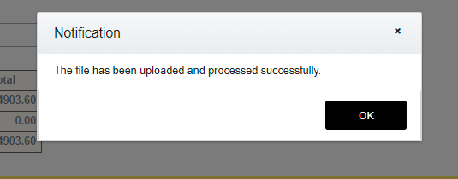

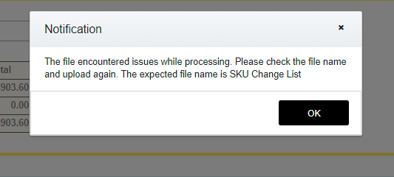

* + **Table: Data table (SKU CHANGE LIST data)**
    - The data in the table is filtered based on the “Fashion Season” selected in Filter 1 of section 1.
    - The first column lists the Fashion Season which matches with the value selected in Filter 1 of section 1.
    - The second column lists the OLD SKUs from SKU CHANGE list for the fashion season selected.
    - The third column lists the NEW SKUs from SKU CHANGE list for the fashion season selected.
    - The fourth column is a flag if the orders pertaining to selected season and old SKU should be dropped and should not make it into final buy orders.
    - The fifth and sixth columns “Level” and “Level ID” are used for determining the level at which this specific SKU change should be applied at. There are 3 possible values for “Level”.
      * Corporate – means the SKU change impact should be applied to ALL orders.
      * Channel – means the SKU change impact should be applied to a specific Channel. The Channel name will be picked up from the next column which is “Level ID”.
      * Account – means the SKU change impact should be applied to orders pertaining to this specific account / customer. The customer code will be picked up from the next column which is “Level ID”.



* + - The seventh column allows the user to update that specific record. Clicking on the update button changes the record / row on the screen for in-line editing as shown in the snapshot below. After editing the editable fields, the user can save or cancel by clicking on either of the icons from Update column.

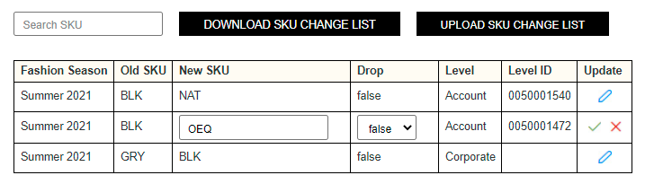

* + - After editing the editable fields, the user can save or cancel by clicking on either of the icons from Update column as shown above.
    - **Validation:** Upon saving the updates, a validation on New SKU is done to check whether the updated SKU exists in the Orders SKU list. The update is preserved only if the SKU exists in the list otherwise the update is rejected.

## UPC Validation Screen

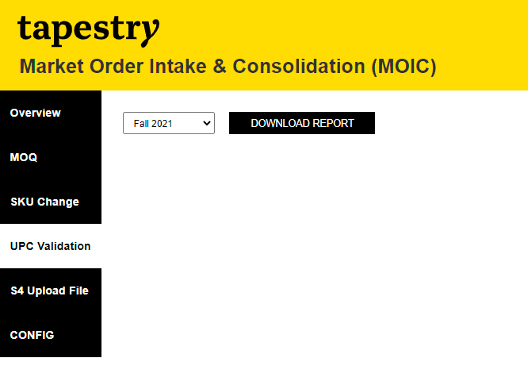

* **Section 1 contains:**
  + **Filter 1: Fashion Season**
    - This is populated with distinct Season Names which come from Joor Orders (Orders Data)
    - Default selection is the first value in the list
  + **Button: DOWNLOAD REPORT**
    - Clicking on this button downloads the SKU names which DO NOT have any UPC code associated in the orders data (final buy orders) in the database in form of an excel file.
    - The name of the download file will be “UPC Validation Report” + <<Fashion Season>> selected from the dropdown + date time stamp.
    - For e.g. UPC Validation Report_Fall 2021_24-02-2021 13_35_49.xlsx
    - The SKU names will be filtered based on the selection in filters Fashion Season.

## S4 Upload File Screen

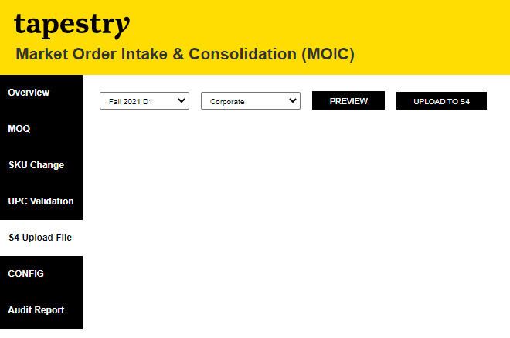

* **Section 1 contains:**
  + **Filter 1: Fashion Season**
    - This is populated with distinct Season Names which come from Joor Orders (Orders Data)
    - Default selection is the first value in the list
  + **Filter 2: Channel**
    - This is populated with Channels which are pre-populated in the Channel look up table
    - Default selection is the first value in the list
  + **Button: Preview**
    - Clicking on this button will download all the Orders that “will” be pushed to S4 when the upload to S4 button is clicked. This gives a preview of all the orders prior to actually pushing the orders to S4. The download file name is <<Preview_FinalBuy_Season_Channel_timestamp.xlsx>>
  + **Button: UPLOAD TO S4**
    - Clicking on this button shows a confirmation pop up to the user as shown below asking whether they are sure of sending the final buy orders to S4. Clicking “NO” will bring the user back to previous screen. Clicking “YES” will move the final buy orders from main MOIC table to Outbound MOIC table from where a scheduled ETL job extracts and sends it to S4.

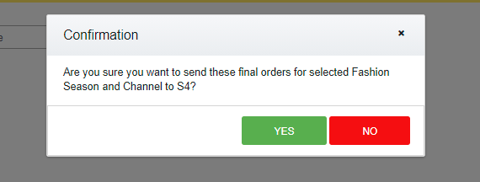

* + - When user clicks on the “YES” button on the confirmation pop up, if there are no matching records for the selected fashion season and channel, the user will be shown a message stating “No matching records found” as shown in the below snapshot.

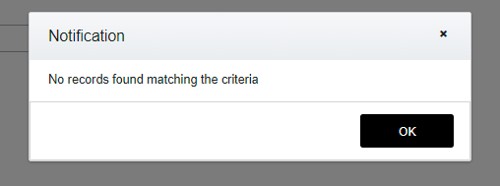

## Config Screen

This is the screen through which users can manage the customer master data. The customer data comes in from S4 into MOIC. Within MOIC, some new attributes get associated to customer such as Channel, Segment, Retail price currency, Wholesale price currency, etc.

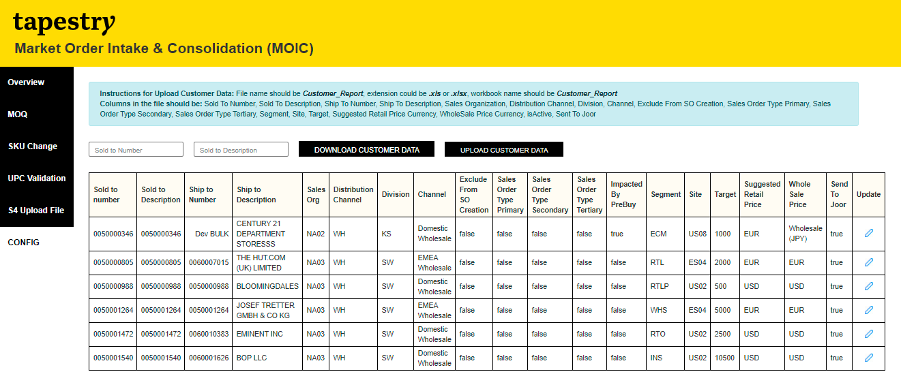

* **Section 1 contains:**
  + **Search Box: Sold To Number**
    - This enables user to search and narrow down the customer list displayed on the screen based on customer code.
    - The search happens on “Sold To Number” column as soon as a character is typed in the search box.
    - The result set in the data table gets narrowed down based on user’s input in the search box as shown in the snapshots below

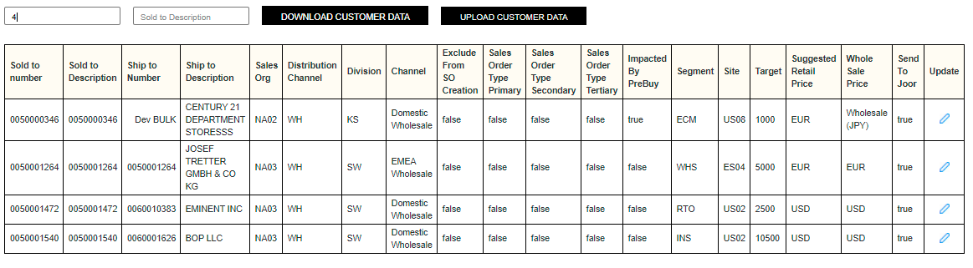

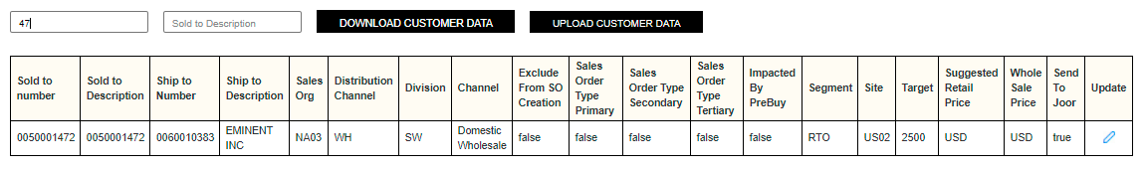

* + **Search Box: Sold To Description**
    - This enables user to search and narrow down the customer list displayed on the screen based on customer name.
    - The search happens on “Sold To Description” column as soon as a character is typed in the search box.
    - The result set in the data table gets narrowed down based on user’s input in the search box as shown in the snapshots below
    - If both the search boxes are used, the search query is done with an “AND” meaning filtering of the data happens considering both the columns; “Sold To Number” and “Sold To Description”.

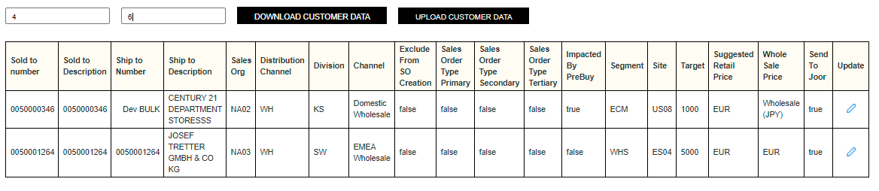

* + **Button: DOWNLOAD CUSTOMER DATA**
    - Clicking on this button downloads the customer data in form of an excel file.
    - All the customers from MOIC customer master table will be downloaded in the file.
    - The name of the download file will be “Customer Report” + date time stamp.
    - For e.g. Customer Report_24-02-2021 14_57_36.xlsx
  + **Button: UPLOAD CUSTOMER DATA**
    - Clicking on this button lets the user upload customer data into the MOIC customer master table.
    - The instructions for uploading Customer data (such as file name expected, columns expected in the file, etc.) are displayed on the screen itself as shown in snapshot below.
    - A message is displayed to the user on the screen upon successful upload or in case of any failure. An example is shown in the snapshots below.



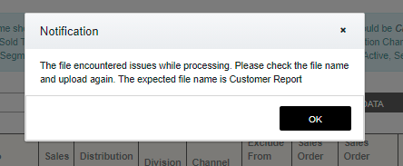

* + **Table: Data table (Customers data)**
    - Only the customers that have “isActive” flag as True in database will be displayed in this table.
    - Clicking on the Update icon from last column will convert that specific row into an “in-line” editing mode as shown in below snapshot.

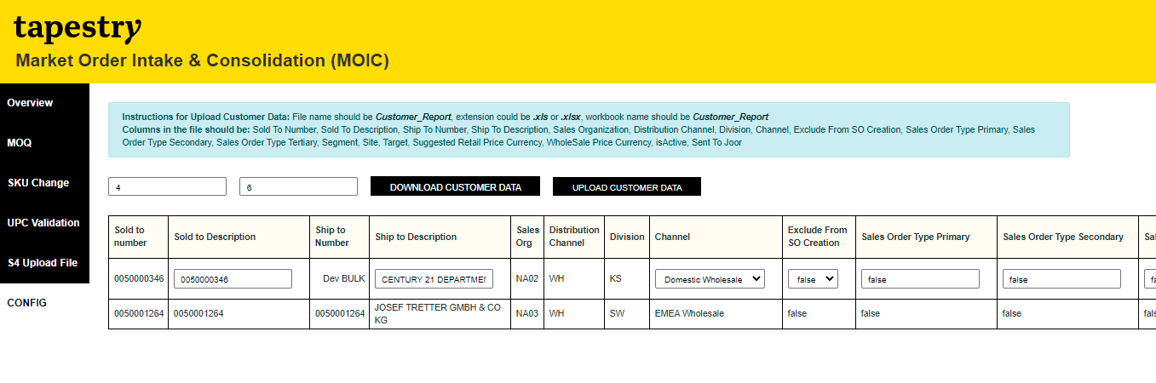

* + - After editing the editable fields, the user can save or cancel by clicking on either of the icons from Update column.
    - The updated data gets saved in the customer master table and a message is displayed to the user for both success and failure scenarios. One example is shown below.

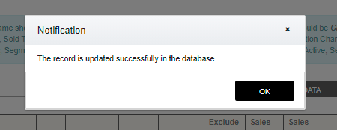

## Audit Report

This screen will only be used by the “Admin” users of MOIC. From this screen, the user can generate an audit report.

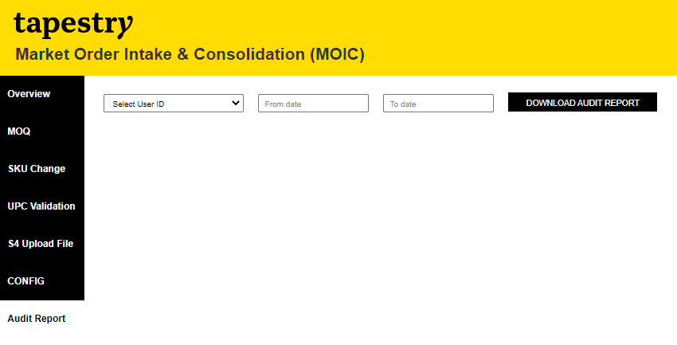

* **Section 1 contains:**
  + **Drop Down: User ID**
    - This enables admin to select the MOIC user for which the audit report needs to be downloaded. The dropdown lists all the users that will be active in the system. The user list comes from the “users” table.
  + **Calendar: From Date**
    - The admin can select the date range (From date) to filter the audit report for a specific period.
  + **Calendar: To Date**
    - The admin can select the date range (To date) to filter the audit report for a specific period.
  + **Button: DOWNLOAD AUDIT REPORT**
    - Clicking on this button will download a report in an excel format. The file name is <<Audit Report_FromDate_ToDate_UserID_timestamp.xlsx>>
    - The report will have 4 work books.
      * Customer Report – work book lists all the customer data that is impacted by the selected user.
      * MOQ List – work book lists all the MOQ List data that is impacted by the selected user.
      * SKU Change List – work book lists all the SKU Change List data that is impacted by the selected user.
      * Pre Buy List – work book lists all the Pre Buy List data that is impacted by the selected user.

# Uploads

The functionality to upload some specific data set is also provided in MOIC through “Upload” buttons on the screens.

There are the following 4 data sets that can be uploaded in the MOIC by users who are authenticated to use MOIC.

1. Customer Data – through Config screen
2. MOQ List – through MOQ screen
3. SKU Change – through SKU Change screen
4. Pre Buy List – through MOQ screen

This section provides details of each of the 4 upload such as file extension, file name, validations that get triggered, etc. This will enable users to use the correct file for uploading into MOIC.

## Customer Data Upload

The users can upload customer master data through this functionality from Config screen. As such, the important details like file name, extension, etc. are already shown on the Config screen, following are the details that the user need to keep in mind when uploading customers.

* File name should be **Customer_Report**
* File extension could be **.xls or .xlsx**
* Workbook name (within the excel file) should be **Customer_Report**
* Columns in the file should be as defined in the below table

|  |  |
| --- | --- |
| **Column Name** | **Remarks** |
| Sold To Number | This is the customer code from SAP |
| Sold To Description | This is the customer name from SAP |
| Ship To Number |  |
| Ship To Description |  |
| Sales Organization |  |
| Distribution Channel |  |
| Division |  |
| Channel | Can only have one of the below values or leave it blank  Domestic Wholesale  EMEA Wholesale  KDF Wholesale  SEA Wholesale  China TR Wholesale  Off Price Wholesale |
| Exclude From SO Creation | True / False |
| Sales Order Type Primary | True / False |
| Sales Order Type Secondary | True / False |
| Sales Order Type Tertiary | True / False |
| Segment | Can only have one of the below values or leave it blank  ECM  RTL  RTLP  WHS  RTO  INS |
| Site |  |
| Target |  |
| Suggested Retail Price Currency | Can only have one of the below values or leave it blank  EUR  USD  GBP  CHF  CAD  JPY |
| WholeSale Price Currency | Can only have one of the below values or leave it blank  EUR  USD  GBP  CHF  CAD  JPY |
| isActive | True / False |
| Sent To Joor | True / False |

* Validations:
  + File name check, file extension check, and file workbook name check, column names and sequence check. If any of these are incorrect, the file will be rejected and a message is displayed to the user.
  + If the customer already exists in the MOIC customer master table, update the record in the table.
  + If the customer does not exist in the MOIC customer master table, create a new record in the table.
  + Channel, Segment, Currency fields – if these have any other values than acceptable as mentioned in the table above, the file will be rejected and a message is displayed to the user.
  + For all Boolean fields, only the values True or False will be accepted. No other values such as “Y” or “N” or “T” or “F” are accepted.

## MOQ List Upload

The users can upload MOQ list through this functionality from MOQ screen. As such, the important details like file name, extension, etc. are already shown on the MOQ screen, following are the details that the user need to keep in mind when uploading customers.

* File name should be **MOQ List**
* File extension could be **.xls or .xlsx**
* Workbook name (within the excel file) should be **MOQ List**
* Columns in the file should be as defined in the below table

|  |  |
| --- | --- |
| **Column Name** | **Remarks** |
| Season |  |
| SKU | This should be in the format  Item number + SPACE + item color code + SPACE + item size + SPACE + item width  For products that do not have size,    Item number + SPACE + item color code |
| Delete | True / False |
| Effective Date | mm-dd-yyyy |

* Validations:
  + File name check, file extension check, and file workbook name check, column names and sequence check. If any of these are incorrect, the file will be rejected and a message is displayed to the user.
  + SKU will be checked if it exists in the SKUs that come from Joor Orders. If it does not exist in that list, the file will be rejected and a message is displayed to the user.
  + If Delete flag is set to True, that record will not get displayed on the screen.
  + For all Boolean fields, only the values True or False will be accepted. No other values such as “Y” or “N” or “T” or “F” are accepted.

## SKU Change Upload

The users can upload SKU Change list through this functionality from SKU Change screen. As such, the important details like file name, extension, etc. are already shown on the SKU Change screen, following are the details that the user need to keep in mind when uploading customers.

* File name should be **SKU Change List**
* File extension could be **.xls or .xlsx**
* Workbook name (within the excel file) should be **SKU Change List**
* Columns in the file should be as defined in the below table

|  |  |
| --- | --- |
| **Column Name** | **Remarks** |
| Season |  |
| OldSKU | This should be in the format  Item number + SPACE + item color code + SPACE + item size + SPACE + item width  For products that do not have size,    Item number + SPACE + item color code |
| NewSKU | This should be in the format  Item number + SPACE + item color code + SPACE + item size + SPACE + item width  For products that do not have size,    Item number + SPACE + item color code |
| Drop | True / False |
| Level | Can only have one of the below 3 values  Corporate  Channel  Account |
| LevelID |  |
| Delete | True / False |
| Effective Date | mm-dd-yyyy |

* Validations:
  + File name check, file extension check, and file workbook name check, column names and sequence check. If any of these are incorrect, the file will be rejected and a message is displayed to the user.
  + OldSKU and NewSKU will be checked if it exists in the SKUs that come from Joor Orders. If it does not exist in that list, the file will be rejected and a message is displayed to the user.
  + If Delete flag is set to True, that record will not get displayed on the screen.
  + For all Boolean fields, only the values True or False will be accepted. No other values such as “Y” or “N” or “T” or “F” are accepted.

## Pre Buy Upload

The users can upload Pre Buy list through this functionality from MOQ screen. As such, the important details like file name, extension, etc. are already shown on the MOQ screen, following are the details that the user need to keep in mind when uploading customers.

* File name should be **Pre Buy List**
* File extension could be **.xls or .xlsx**
* Workbook name (within the excel file) should be **Pre Buy List**
* Columns in the file should be as defined in the below table

|  |  |
| --- | --- |
| **Column Name** | **Remarks** |
| Season |  |
| SKU | This should be in the format  Item number + SPACE + item color code + SPACE + item size + SPACE + item width  For products that do not have size,    Item number + SPACE + item color code |
| IsPreBuySKU | True / False |
| COO | The only values accepted are:   * Non-Asia * Asia |

* Validations:
  + File name check, file extension check, and file workbook name check, column names and sequence check. If any of these are incorrect, the file will be rejected and a message is displayed to the user.
  + SKU will be checked if it exists in the SKUs that come from Joor Orders. If it does not exist in that list, the file will be rejected and a message is displayed to the user.
  + For all Boolean fields, only the values True or False will be accepted. No other values such as “Y” or “N” or “T” or “F” are accepted.
  + For COO field, the only accepted values are “Non-Asia” or “Asia”.